|  |  |  |  |
| --- | --- | --- | --- |
| **Teacher Candidate:** Barbra Skawski | | **Date:** Nov. 19 | **Title:** Rolling Comprehension |
| **Grade:** 5 | **Subject:** Language Arts | **Unit:** Reading Comprehension | **Lesson #:** Mid-lesson |
| **Core Competency:** Critical Thinking | | **Profile:** 4 (I can gather and combine new evidence with what I already know to develop reasoned conclusions, judgments, or plans). | |
| **Big Idea:** Questioning what we hear, read, and view contributes to our ability to be educated and engaged citizens. | | **Content:** Literary elements: narrative structures and characterization. | |
| **Essential Question:** Can students identify the narrative structures and characterization in the story, in their own words? | | | |
| **Curricular Competencies:** Apply a variety of thinking skills to gain meaning from texts. | | | |
| **Indigenous Perspectives and FPPL:** Learning is embedded in memory, history, and story. | | | |
| **Learning Intention:** Students will be able to identify literary elements: narrative structures and characterization. | | | |
| **Materials:**   * Beach ball labelled with literary elements (Protagonist, antagonist, setting, theme, exposition, conflict, rising action, climax, falling action and resolution). * Template with literary elements for students to identify (See attached template). * Poster on classroom wall with elements and definitions for a reference (See attached). * Exit Slip (See attached). | | | |
|  | | | |

**Introduction -** Activate and Engage:  *Is the intention clear to the class? How can I hook students into the topic? e.g. relate the lesson to their lives, connect to prior learning, video clip, reading, hands on activity? Include Teacher AND Student Activities.*

|  |  |
| --- | --- |
| Approx  Time  10 Min. | The class would have previously read the book A boy Called Bat by Elana K. Arnold.  ‎A Boy Called Bat  As a class create and discuss the summary of the book. The events that happened in order and the main or big ideas. This can be done using a timeline on the white board.  If you need a quick summary of the book to familiarize yourself before the lesson visit the link provided <https://www.supersummary.com/a-boy-called-bat/summary/> |

**Body -** Explore and Discover: *What SPECIFIC strategies or tactics will I use to ensure there are opportunities for students to acquire new information (e.g., mini lesson, cooperative learning, reading and responding, research, viewing and discussing)? Are there multiple ways for students to acquire and practice new learning? What questions can I ask to discover how learning is going (formative assessment)? Include Teacher AND Student Activities.*

|  |  |
| --- | --- |
| Approx  Time  25 Min. | Activity #1   * Have students sit in a circle on the floor * Roll the labelled beach ball to a student, that student will identify the literary element in *A Boy Called Bat* that their thumb lands on. * That student will then roll to another student. * Students will repeat this process until all elements have been identified.   Activity #2   * Students will go back to their desks and work independently * Students will fill out the template provided of the literary elements of the story in their own words. * Students can refer to the poster displayed on the classroom wall of the literary elements and definitions as needed (provided below). |

**Closure -** Organize and Integrate: *How will students “cement” their learning? What techniques will help them reflect, personalize and stretch their thinking? How will I tie back into the outcomes and learning intentions? How will I summarize or review? How will I know they have demonstrated the intention? Include Teacher AND Student Activities.*

|  |  |
| --- | --- |
| Approx  Time  10 Min | Students will fill out the exit slip provided below before exiting class for recess.  They will match the definitions with the proper literary element term.  For this activity, take down the poster on the wall so students can demonstrate what they have learned on their own. |

|  |  |
| --- | --- |
| **Tier 2/Tier 3: (Adaptations/Modifications)**  Students can answer fewer elements on the template  Students can have someone scribe for them while they describe in their own words, the different parts of the story. | **Extensions:**  Students can use this template with their silent reading book (Practicing the elements with other stories they have read in the past).  Students could be given the part of the story, then they must identify what element it is (backwards activity from the original activity). |
| **Assessment Plan:**  Assessment will be done through observing students’ comprehension through their exit slips. | |
| **Lesson Notes/Reflection:** | |

Note: See below for template, poster, and exit slip.

Literary Elements of “The Boy Called Bat,” by Elana K. Arnold

Instructions:

In your own words describe or identify each element in “The Boy Called Bat.”

|  |  |
| --- | --- |
| Character | |
| Protagonist | Antagonist |

|  |  |
| --- | --- |
| Setting | Theme |

|  |
| --- |
| Plot |
| Exposition |
| Conflict |
| Rising Action |
| Climax |
| Falling Action |
| Resolution |

Literary Elements Poster

|  |  |
| --- | --- |
| Protagonist | Main character |
| Antagonist | Opposing character or force that works against main character |
| Setting | Time, place, and environment the story is taking place |
| Theme | Central idea or message the author is trying to convey |
| Exposition | Introduction of the story that gives important background information |
| Conflict | A problem the character faces during the story. Can be an internal or external problem. |
| Rising Action | The part of the story where the problem begins and leads to the climax. |
| Climax | When all the elements of the story come together. The most intense part of the story. |
| Falling Action | The part of the story that leads to a resolution. Comes after the climax. |
| Resolution | Final act or conclusion of a story. The problem or conflict is resolved. |

Literary Elements Exit Slip

Instructions: Match the definition to the literary element

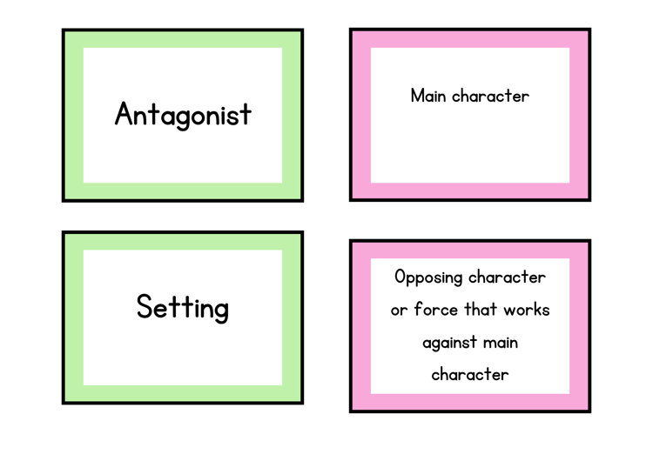

Can you identify your term in the book?